**Search Agents**

**Uniformed search**

* Use no domain knowledge
* Strategies:
  + Breadth-first search (BFS)

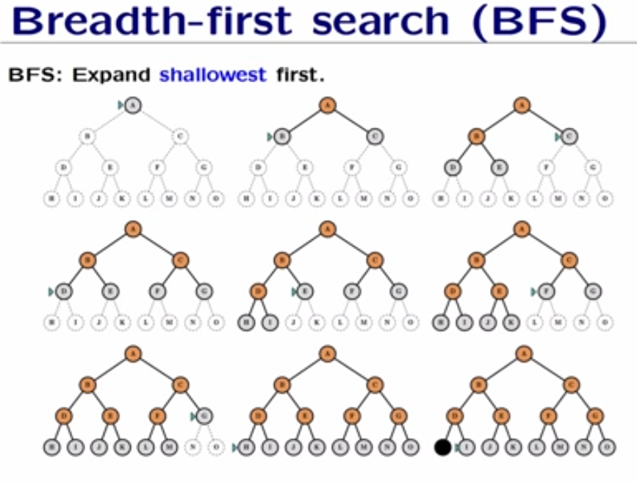

**Algoritm:**

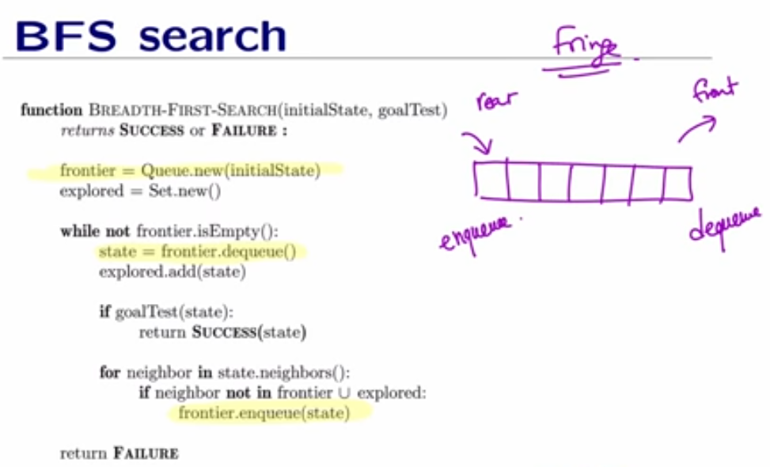

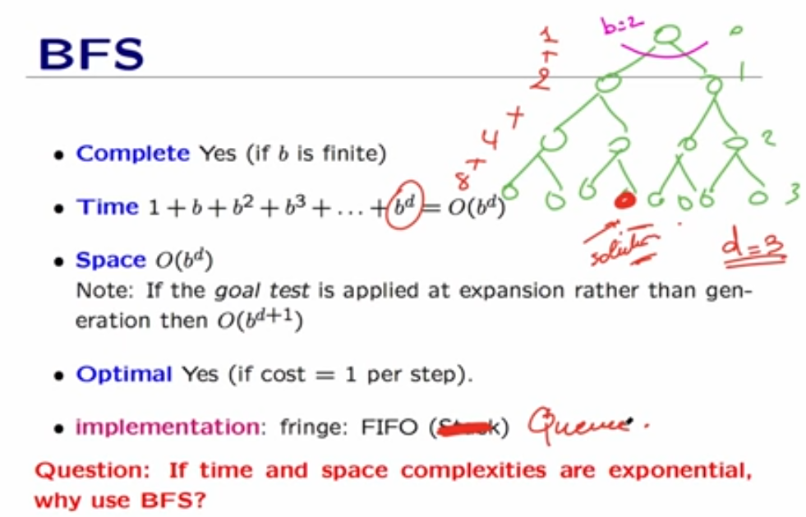

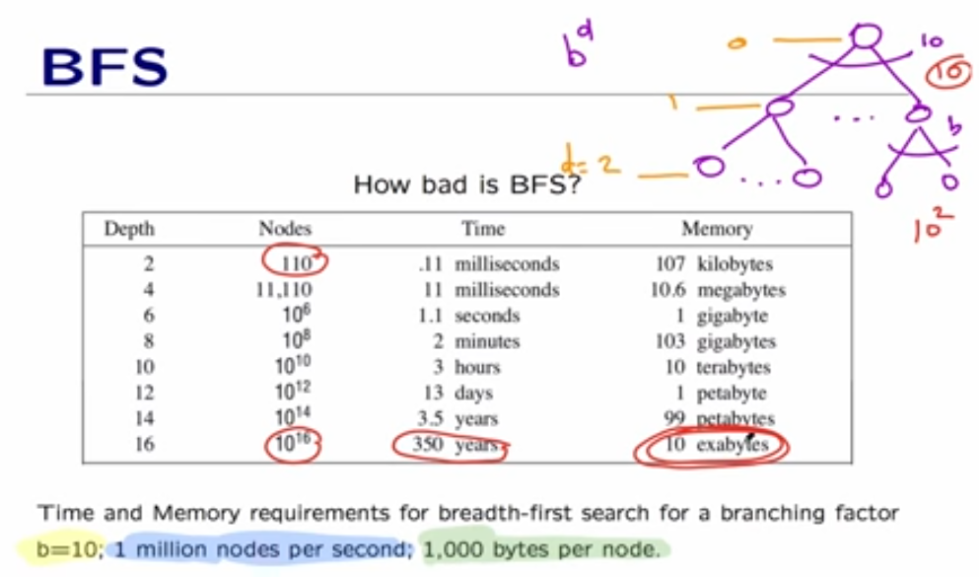



* + Depth-first search (DFS)
  + Depth-limited search
  + Iterative-deepening search